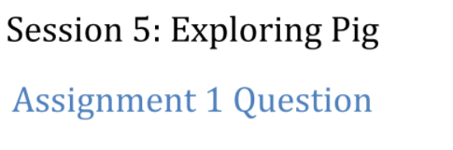

Problem statement

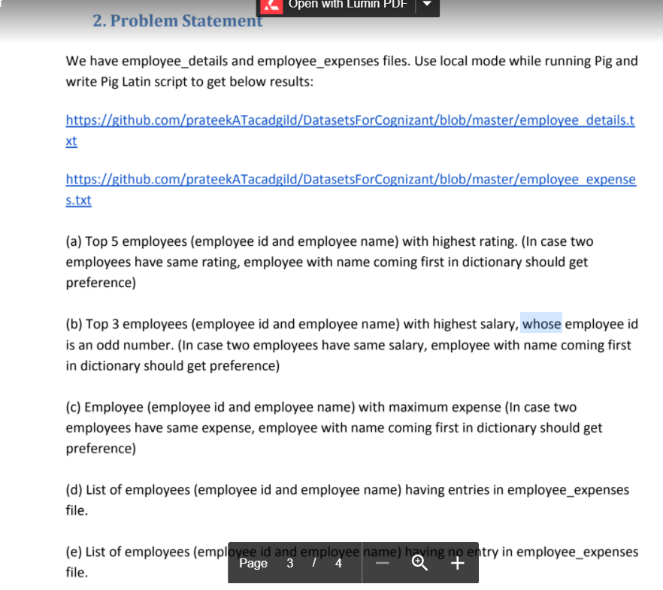

<https://github.com/prateekATacadgild/DatasetsForCognizant/blob/master/employee_expenses.txt>

<https://github.com/prateekATacadgild/DatasetsForCognizant/blob/master/employee_details.txt>

Task A

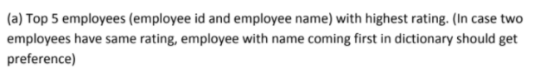

Load the data

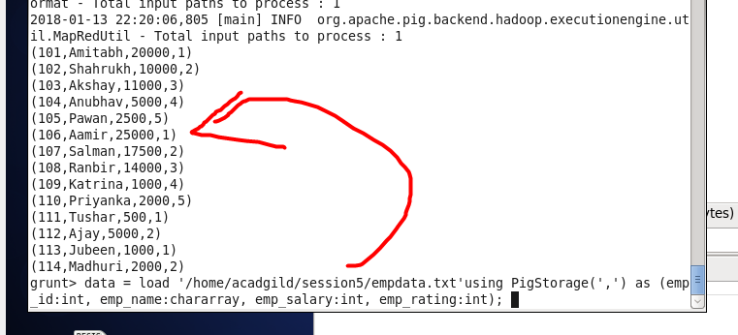

Solution and Result :

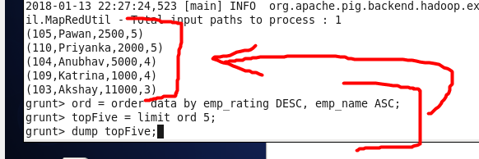

Task B

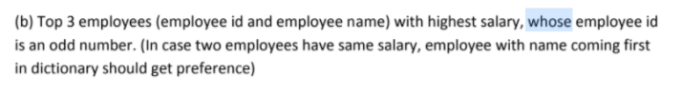

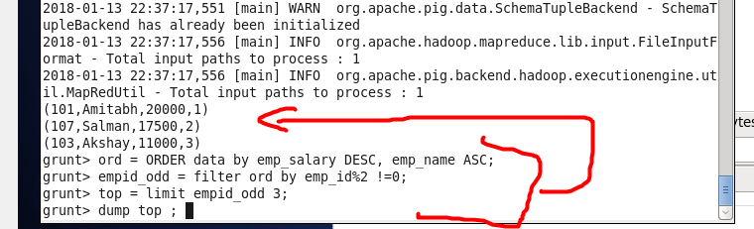

Task C

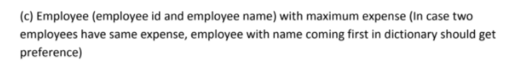

Load data:

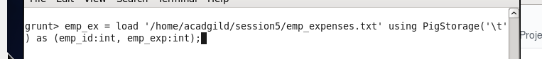



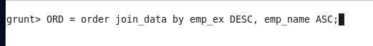

Dump the result :

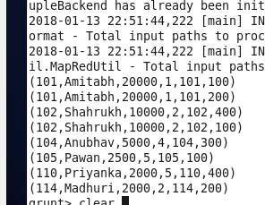

Task D

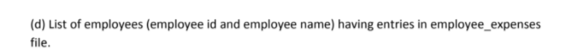

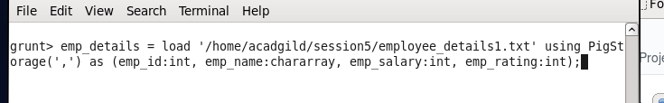

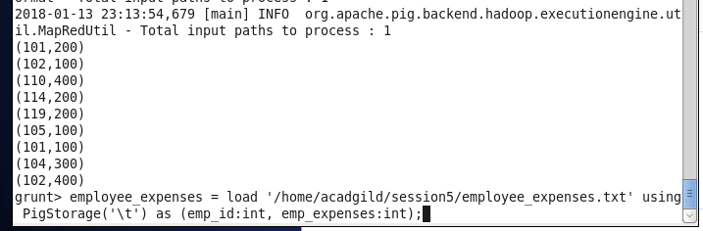

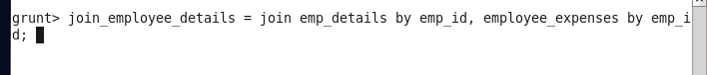

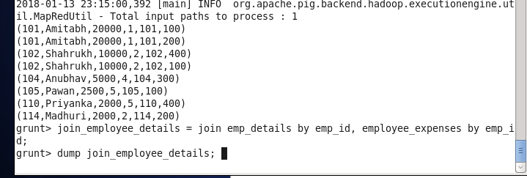

Result :

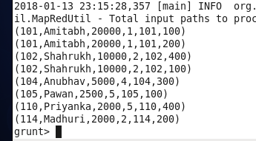

Task E

